Ryan Timbrook

Version 1.0
8/13/2018

Revision History
Date | Version | Description | Author(s)
8/13/2018 | 1.0 | Part 1, Summary of project; Includes Conceptual Model; Includes Normalized Logical Model | Ryan Timbrook
9/10/18 | 2.0 | Part 2, Includes Physical Database Design; Data Creation Examples; Data Manipulation Examples; Code snippets that provide examples of how the data answers questions posed in the summary | Ryan Timbrook

Table of Contents
1 Introduction 4
1.1 Purpose 4
1.2 Scope 5
2 Conceptual Model 6
2.1 Description 6
2.2 E-R Diagram 6
3 Normalized Logical Model 7
3.1 Description 7
3.1.1 Diagram 7
4 Physical Database Design 9
4.1 Description 9
4.2 Diagram 9
4.3 Table Definitions 9
4.3.1 xxx 9
5 Data Creation 10
5.1 Description 10
5.2 Diagram 10
5.3 Table Definitions 10
5.3.1 xxx 10
6 Data Manipulation 11
6.1 Description 11
6.2 Diagram 11
6.3 Table Definitions 11
6.3.1 xxx 11
7 Answering Data Questions 12
7.1 Description 12
7.2 Diagram 12
7.3 Table Definitions 12
7.3.1 xxx 12
8 Implementation 13
8.1 Description 13
9 Reflection 14
9.1 Description 14

Introduction
The Voice Services team at T-Mobile is developing a new set of Amazon Alexa Skills that are intended for Internal use by employees of T-Mobile. This team is leveraging Amazon's new 'Alexa for Business' AWS service which allows a company to publish Alexa Skills internally and has a management facility for inviting users to use these Skills. The Voice team sees Alexa Skills as the perfect tool for brining awareness to the skeptics of how powerful and efficient voice solutions can be.
Wanting to make a real impression on their users, they've selected a topic which all of the leadership at T-Mobile and other companies spend the majority of their time asking, being questioned on, and researching. These are Key Performance Indicators (KPIs). It's the thing that keeps most business people up at night and is the first thing they are trying to get caught up on every morning. With hundreds, if not thousands, of variabilities that make up KPIs and how they are reported, this is an opportunity to great to ignore.

To be successful in changing their leaders, as well as others, habits and perceptions of voice systems, the Voice team understands that their Skills must be simple to use and personal to the end user. Through investigation, the team has found there's no data source system that maps users to KPIs they own or have responsibility of, nor is there a way of assigning themselves to them. Based on this and the below bullets they have decided to develop a new database for this purpose.

Subset of challenges found:
- No logical mappings exist where a system would know what KPI's a user would be responsible for or interested in knowing about
- Users often aren't aware of the KPIs they are responsible for or what operational parameters these KPIs are composed of
- Organizations change regularly and with it KPIs change as well as People change roles
- KPIs often have the same or similar names across organizations, but are very different in their meaning and data definitions that comprise them
- KPIs are often aggregates at each hierarchy jump in the organization. An example would be organization performance goal metrics. Each team has the same KPI name, but as the hierarchy steps up, the KPIs values are summed at each level.

Purpose
The Voice Services team wishes to create a database that maintains organizational hierarchy data which links a user (employee) to KPIs they are responsible for or have registered to receive reports on. Employees of the DTD organization are software developers who own the applications they build. These employees all belong to well organized teams that are managed by an organization. Each team in the organization has its own sub-hierarchies with varying supervisory levels. The applications these teams build and manage are often referred to as Capabilities and a collection of Capabilities is referred to as a Product. To make it simpler for users of the new Alexa Skill to find the KPIs they are most interested in, KPIs need to be findable based on Product or Capability name searches as well as by Teams within an Organization.

The Voice Services team would like this database to be able to answer questions such as:
- What Employee's belong to a given Organization?
- What Employee's belong to a given Team?
- Who is the Supervisor of a given Organization?
- What KPIs are a given Organization responsible for?
- In an Organization, what Team is responsible for a given KPI?
- For a given KPI, in a Team, who is the primary point of contact and what is their preferred contact channel?
- For a given Employee, what KPIs are they associated to given their Role in the Organization?
- What KPIs are associated to a given Product
- What KPIs are associated to a given Capability
- What KPIs are associated to a given Application
- What Products, Capabilities, and Applications is a given Organization responsible for?

Additional data requirements include:
- An Employee can have one or more Roles
- An Employee can be a Supervisor of zero or more Employees
- An Employee belongs to one or more Teams; A Team has one or more Employees
- A Department has many teams; A Team belongs to one Department
- A Team owns zero or more Applications; An Application is owned by one Team
- Team Names can be duplicated, but not within the same Department
- An Employee can self-register for one or more KPIs
- KPIs are Key Performance Indicators that measure the success of a given Application
- An Employee can search for KPIs that are associated to a Product
- An Employee can search for KPIs that are associated to an Application
- An Employee can search for KPIs that a Team owns
- An Employee can search for KPIs that an Organization owns

Scope
The Database Design will consist of the following:
- Conceptual Model
- Normalized Logical Model
- Physical Database Design
- Data Creation
- Data Manipulation
- Answering Data Questions
- Implementation Screen Shots
- Reflection

Conceptual Model

Description
Below is an entity-relationship model that logically represents the data in which the Voice Services team would like to maintain so that their Alexa KPI Skill will have a personal connection to the Skill user.

E-R Diagram
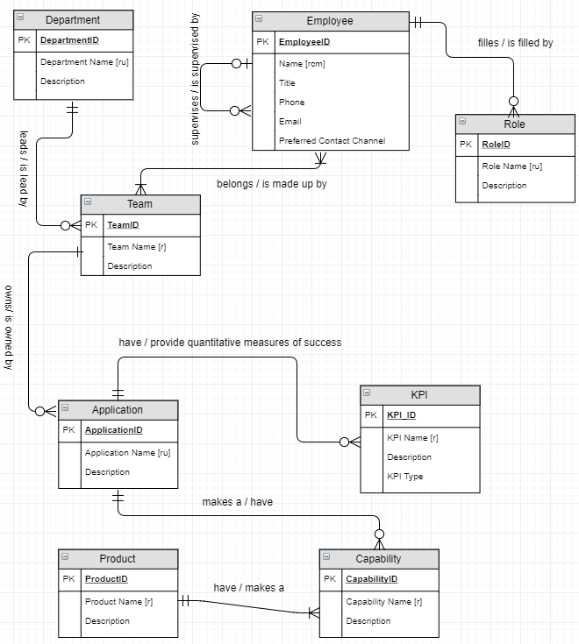

Normalized Logical Model

Description
Below is the logical data model which was crafted after reviewing the A4B Alexa KPI data and normalizing the model. This is the final logical model to be implemented.

Diagram
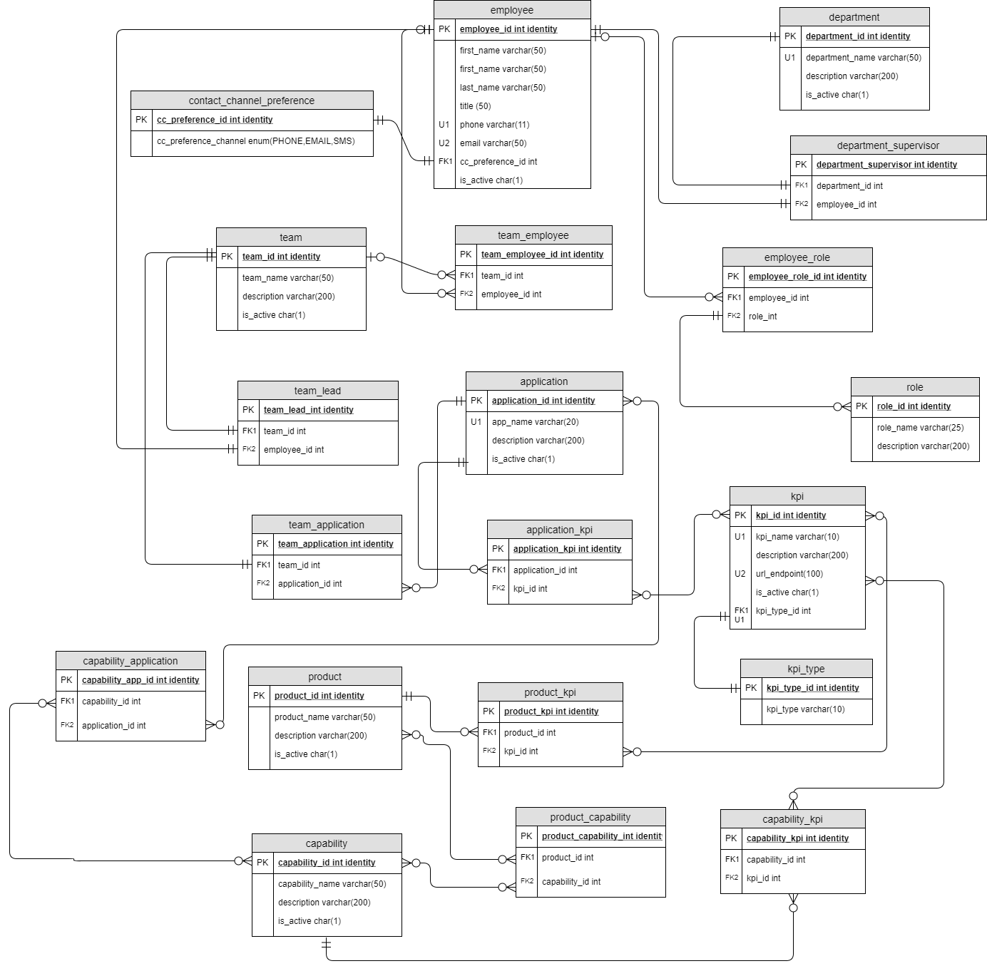

Physical Database Design

Description
X

Diagram

Table Definitions

xxx

Name |  | Data Type | Req’d | Description

Data Creation

Description
X

Diagram

Table Definitions

xxx

Data Manipulation

Description
X

Diagram

Table Definitions

xxx

Answering Data Questions

Description
X

Diagram

Table Definitions

xxx

Implementation

Description

Reflection

Description

